**STEM Nucleo 401re:**

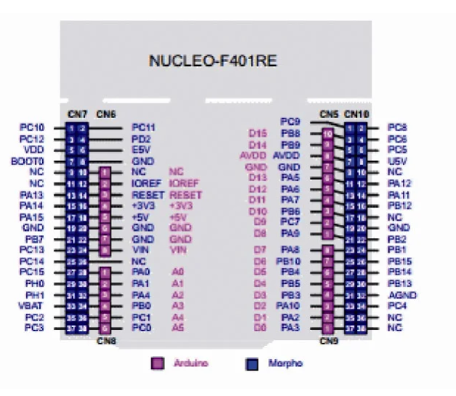

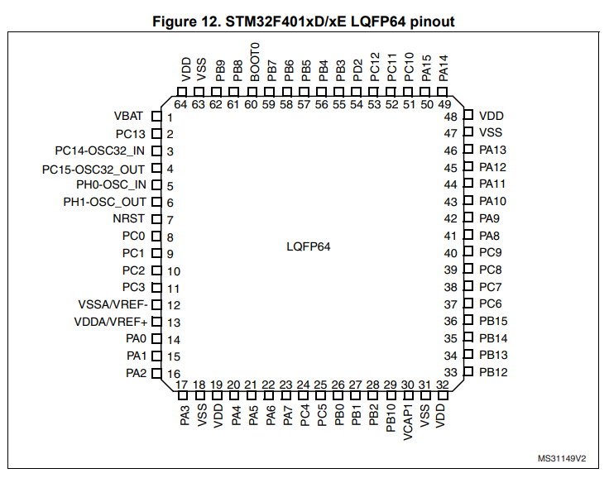

* It is used in the place where faster computation and more memory is needed.
* After programming the board the debugging area can be removed so we get optimized microcontroller.
* Even after removing the debugging part it can be programmed using external wire and it supports serial wire debug protocol which uses two wires instead of five(regular).
* Consumes less power compared to Arduino.
* There are many different ways to communicate with the board such as with three I2C pins, three UART interfaces at 10Mbit/s, four SPI interfaces at 42Mbit/s.

Comparison table**:**

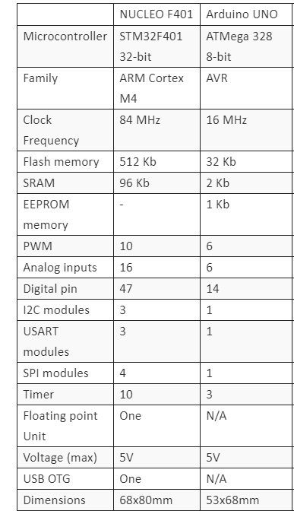

* Comparing to Arduino it has more performance ,input/output pins, faster execution.
* But it is programmed in a different way while Arduino is little straight forward manner.

**Input/output modes:**

GPIO pins can be used in many configurations such as:

* Input floating
* Input pull up
* Input pull down
* Analog
* Output open-drain with pull-up or pull-down capability
* Output push-pull with pull-up or pull-down capability
* Alternative function push-pull with pull-up or pull-down capability
* Alternate function open-drain with pull-up or pull-down capability

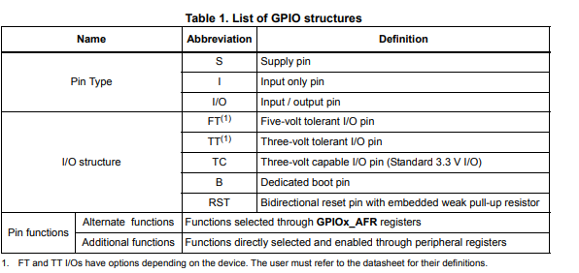

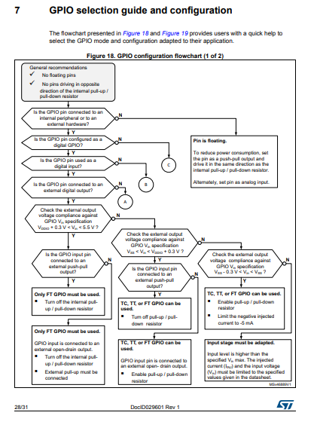

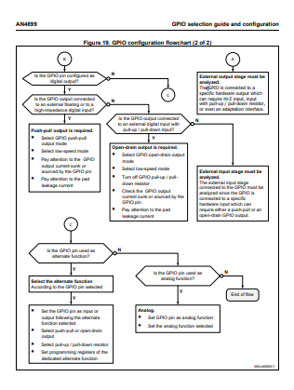

**Circuit diagram for ultrasonic sensor and servomotor:**

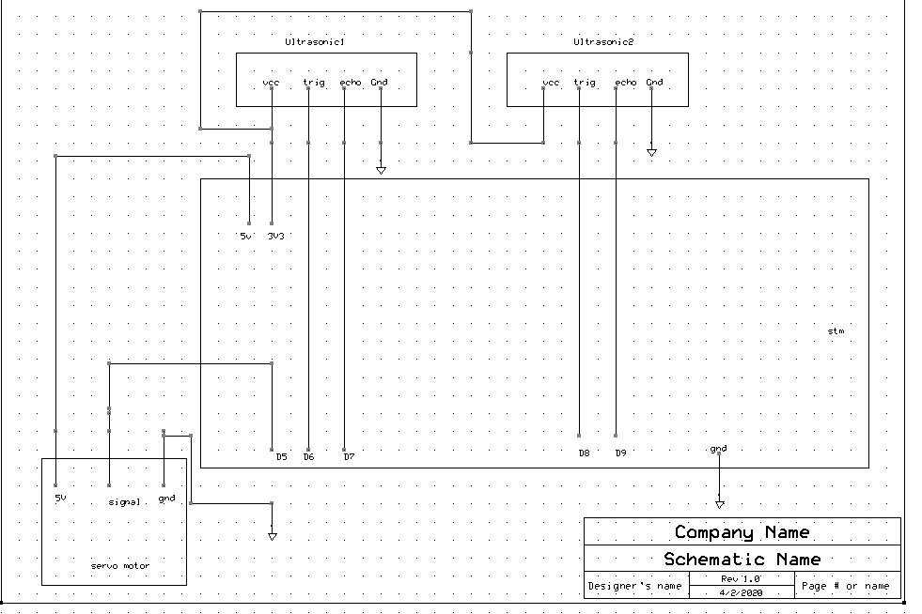

**Reference:**

<https://www.st.com/content/st_com/en/products/evaluation-tools/product-evaluation-tools/mcu-mpu-eval-tools/stm32-mcu-mpu-eval-tools/stm32-nucleo-boards/nucleo-f401re.html>

<https://www.digikey.in/en/maker/blogs/st-nucleo-a-powerful-low-cost-alternative-to-the-arduino>

**ROS (Robot operating system)**

It is a framework to write programs for robots. It has many tools, libraries that make the work easy. Many people from different parts of the world interested in different section of developing a bot contributes their work so making it available for the rest so the work becomes easy. It helps to connect different node one node will send the information and if some other node is interested in that information they subscribes. So this makes works easy and can manage a large number of nodes.

LED array:

#include "mbed.h"

Serial pc(USBTX, USBRX);

//For tens_array

DigitalOut Tens_Led_1(PB_8);

DigitalOut Tens_Led_2(PB_9);

DigitalOut Tens_Led_3(PA_5);

DigitalOut Tens_Led_4(PA_6);

DigitalOut Tens_Led_5(PA_7);

DigitalOut Tens_Led_6(PB_6);

DigitalOut Tens_Led_7(PC_7);

DigitalOut Tens_Led_8(PA_9);

DigitalOut Tens_Led_9(PA_8);

//for ones_array

DigitalOut ones_Led_1(PB_10);

DigitalOut ones_Led_2(PB_4);

DigitalOut ones_Led_3(PB_5);

DigitalOut ones_Led_4(PB_3);

DigitalOut ones_Led_5(PA_10);

DigitalOut ones_Led_6(PA_2);

DigitalOut ones_Led_7(PA_3);

DigitalOut ones_Led_8(PA_0);

DigitalOut ones_Led_9(PA_1);

int main() {

while(1) {

char Tens_array[]={'Tens_Led_1','Tens_Led_2','Tens_Led_3','Tens_Led_4','Tens_Led_5','Tens_Led_6','Tens_Led_7','Tens_Led_8','Tens_Led_9'};//stores pin address of the leds connected to the tense array

char ones_array[]={'ones_Led_1','ones_Led_2','ones_Led_3','ones_Led_4','ones_Led_5','ones_Led_6','ones_Led_7','ones_Led_8','ones_Led_9'};//stores the pin address of the leds connected to the ones array

int fibinocci[]={0,1,1,2,3,5,8,13,21,34,55,89};

int n=pc.getc();

int m,tens,ones;

m=fibinocci[n];

tens=m/10;

ones=m%10;

for(int i=0;i<tens;i++)

{

Tens_array[i]=1;

}

for(int i=0;i<ones;i++)

{

ones_array[i]=1;

}

}

}

Servo motor:

***Pulse length (degrees) = (MAX – MIN) * degrees / 180 + MIN***

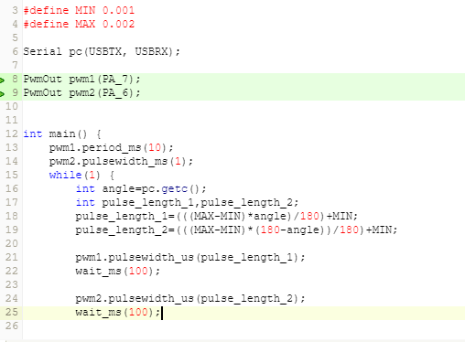

**Agriculture based project:**

For agriculture knowing the nature is very important in that Its very important to know about the crop going to cultivate and equally important to know about the soil in which thwy are going to cultivate. The condition for the varies from crop to crop.

In this bot there will be data related to the suitable soil for various crops. So that the bot can collect the soil and then test the soil and suggest how to improve the soil fertility so that farmer gets more perfect.

The basic things it going to test for:

* pH of the soil
* potassium
* nitrogen
* phosphorous

Components required:

* Arduino UNO
* pH sensor
* Moisture sensor
* TCS3200 color sensor
* Light sensor

Now after creating a mixture that should be tested it is kept on color sensor after detecting the values of R,G,B component in the mixture it comes to an estimation of amount of potassium, phosphorus.

From the pH sensor we get the amount of H+ ions present in it so we get the pH value.

From the moisture sensor we get the amount of moisture content in the soil.

Taking all these values and comparing to the values suitable of agriculture we can calculate the amount of nutrients to be added so that the amount of nutrients is as per the need.

output

Arduino UNO

sensor